**Problem 1. Using print statement**

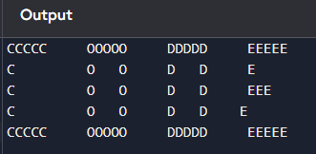

**Problem 1. input**

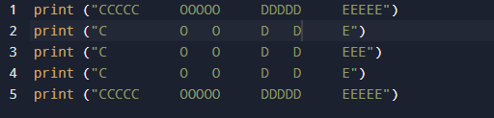

**Problem 2. output**

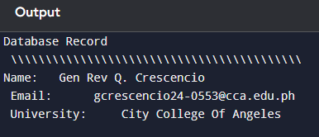

**Problem 2. input**

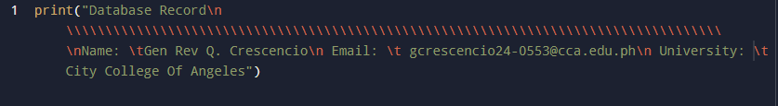

**Problem 3. input**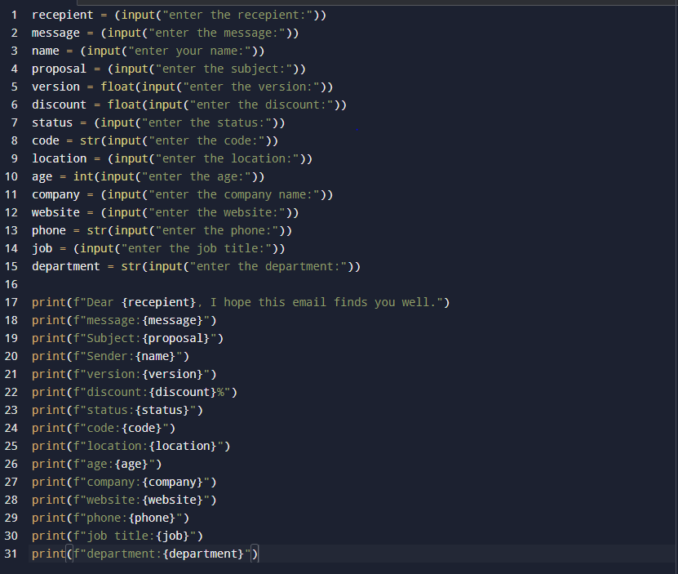

**Problem 3. Output**

